LAB 09

TASK01

When semophore (s)=1 threads=3
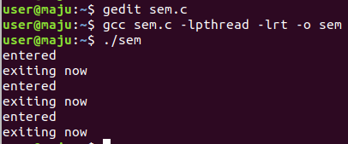

When semophore (s)=5 threads=3
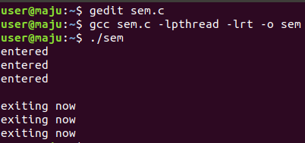

CODE

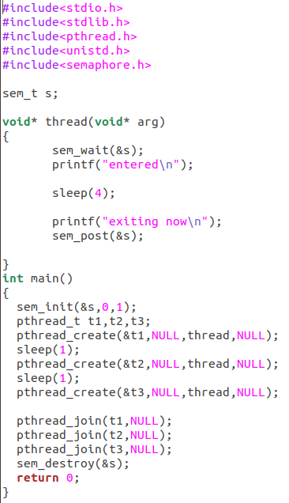

TASK02

